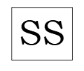
ShopStack
External Design Document (EDD v1)
Prepared by: Tahsin Salsabil
Group 1: Dorian Englisbee, Jasmine Sidhu, Pooja Vyas, Reem Alsamara, Tahsin Salsabil, Tobi Badiru
COMP229: Web Application Development
Prof. Thiago Vitor De Castilho
14th November 2025

Table of Contents
- Introduction and Project Overview Page 3
- Wireframes Page 4
- Initial Screenshots Page 10
- Agile Project Management: Product Backlog and Task Board Page 13

Introduction and Project Overview

This is a first draft of the External Design Document for our project, ShopStack, which is an online shopping website that provides users with a friendly and seamless shopping experience.
This draft of the External Design Document will outline the wireframes for the most top-level features of our site and provide initial screenshots of our progress of the project.
This document will also provide screenshots of the Agile Project tracking tool, Trello, which includes Product Backlog and Task Board.

Wireframes

Homepage:
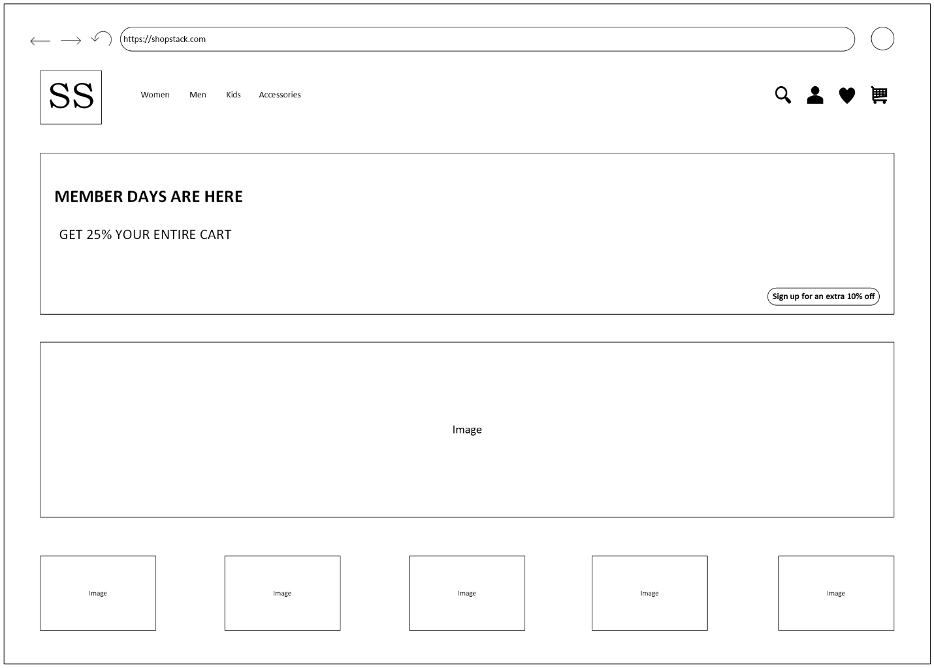

Sign in Page:

Sign Up Page:

All Products Page:

Product Page:

Shopping Cart Page:

Initial Screenshots

Product API Test:
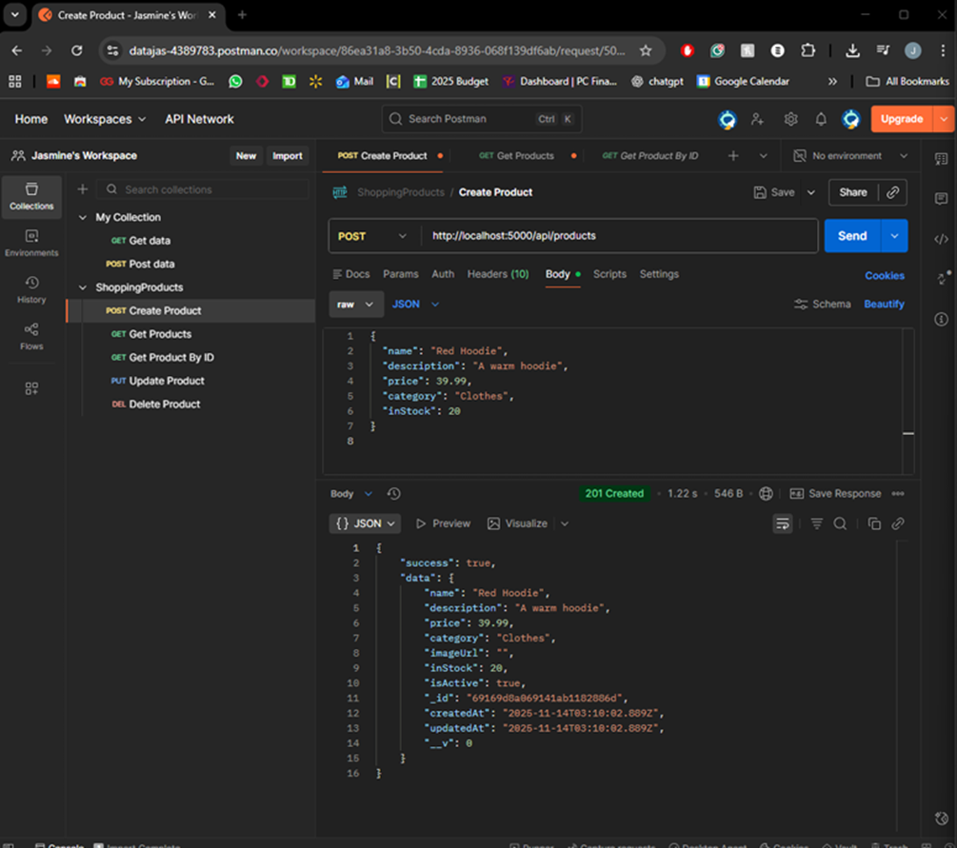

User Routes Implementation:
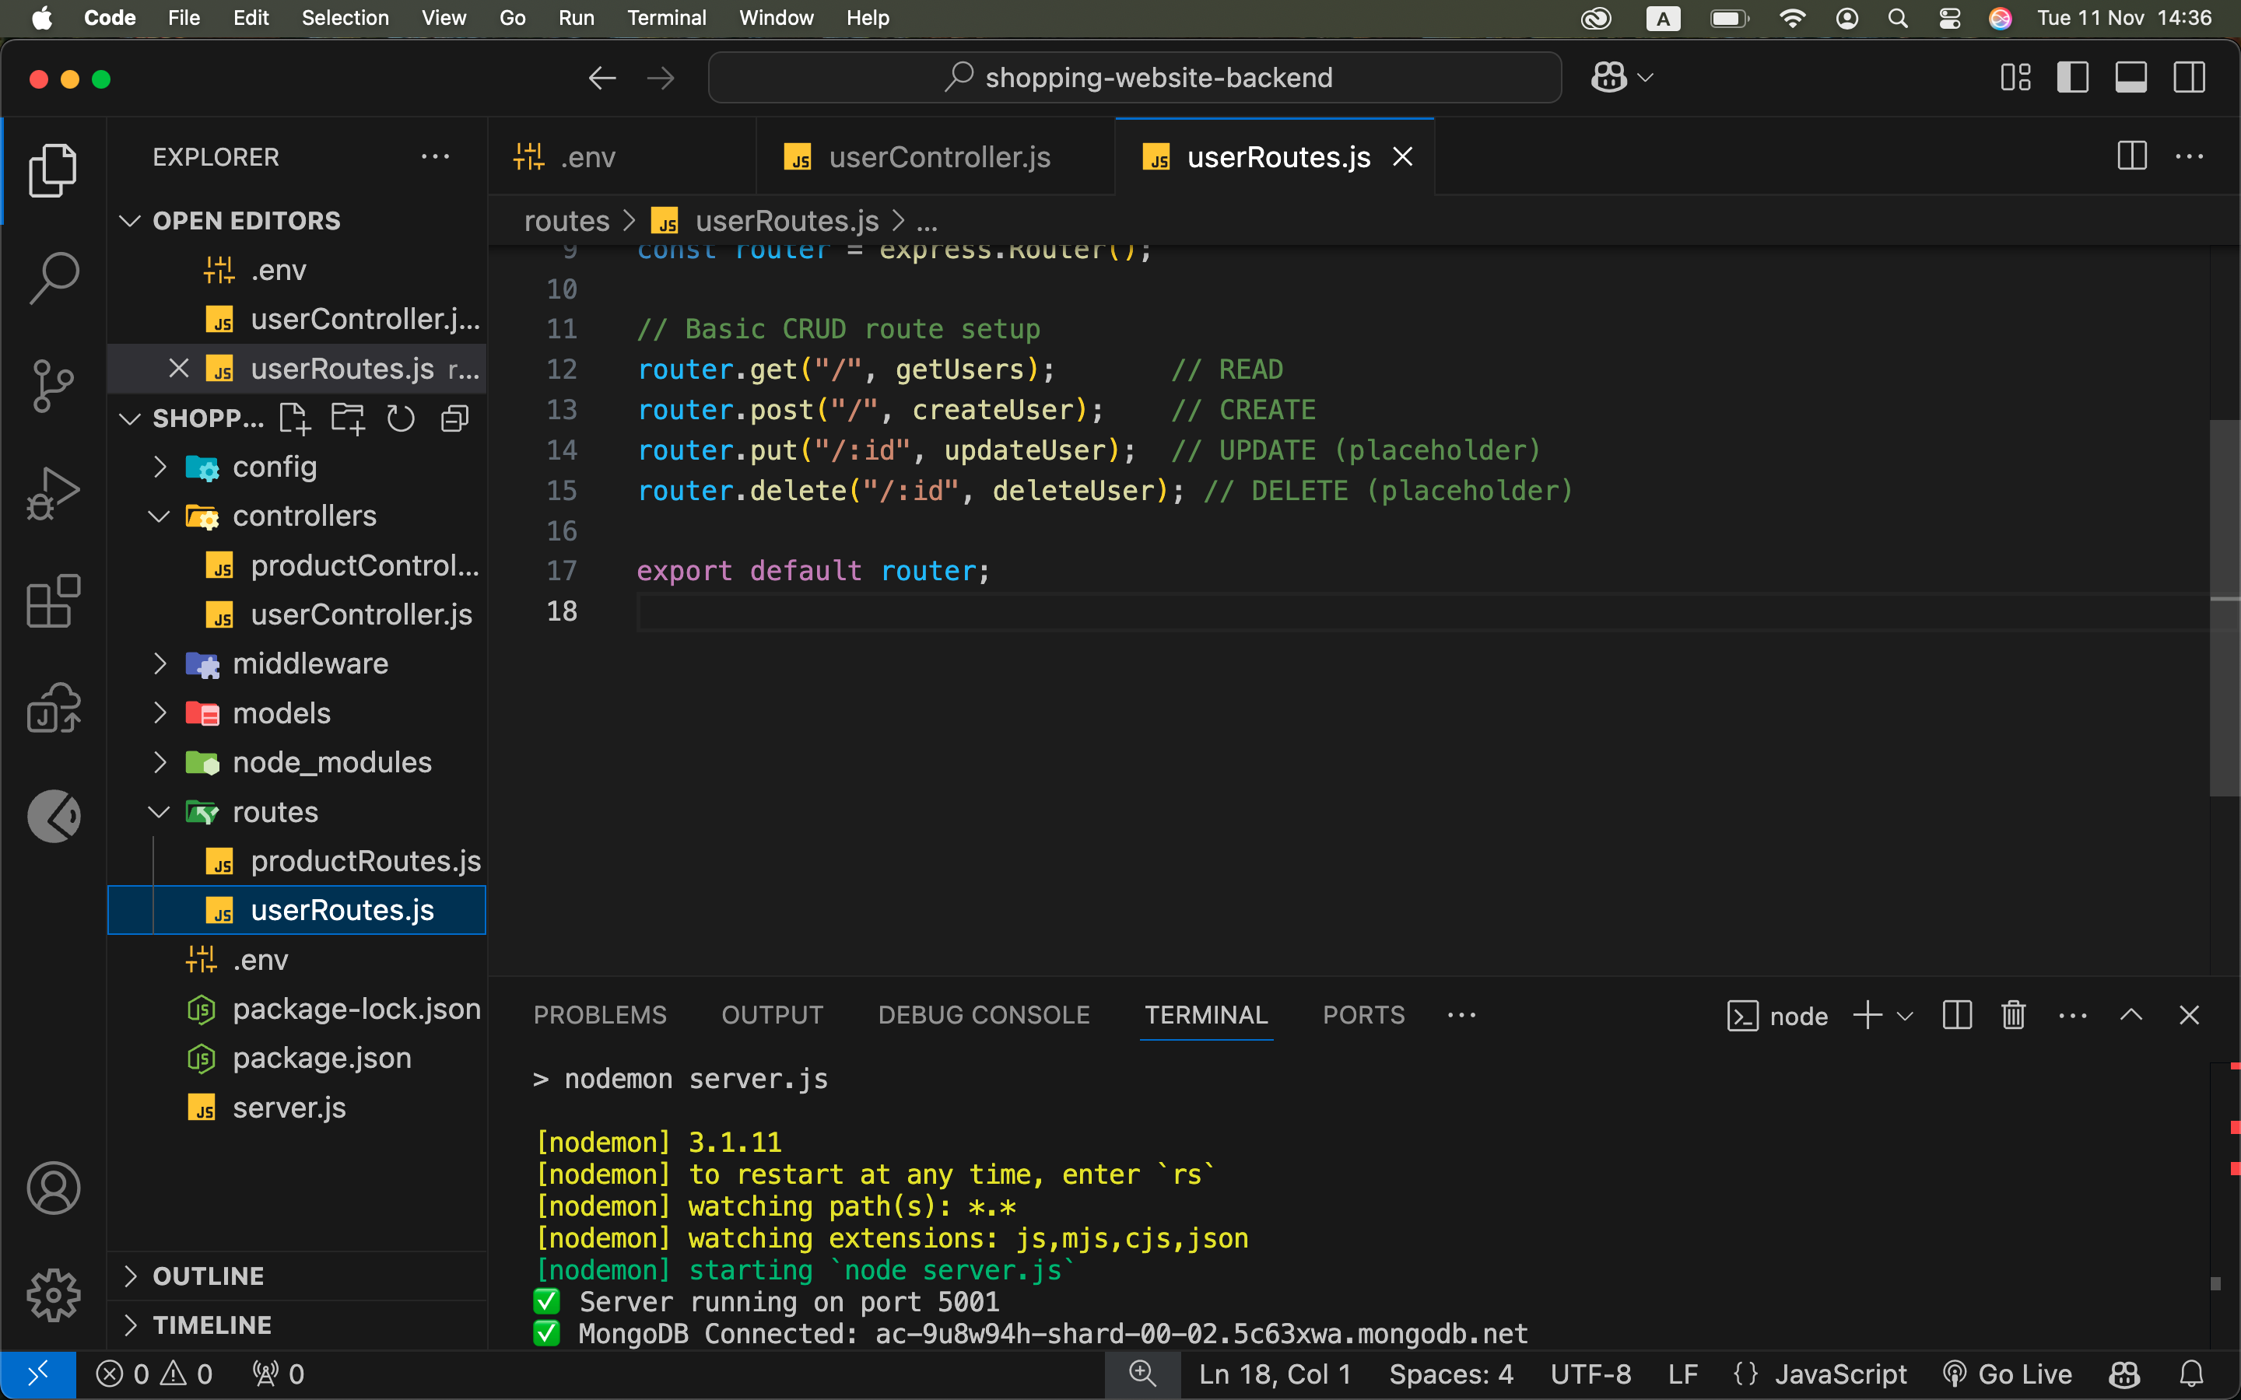

Creating User API Test:
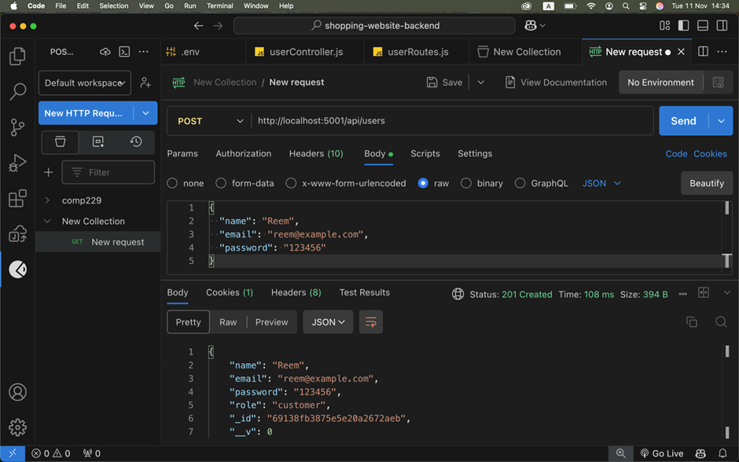

Agile Project Management: Product Backlog and Task Board

